|  |
| --- |
| Famu-fsu college of engineering |
| Final Design Report |
| Team 16: Carbon Nanotube Based Antenna for use on Unmanned Systems |
|  |
| **Natalia Ariza**  **Justin Bosnoian**  **Jolie Breaux**  **Brian Conklin**  **Edwisht Olmann** |
| **11/30/2010** |

|  |
| --- |
|  |

=

Table of Contents

Table of Figures 4

Equations 4

Tables 5

Executive Summary 6

Goal Statement 7

Business Risks Management 8

Concept Generation 8

Design 1 9

Design 2 10

Structural Analysis 11

Measurement Management 12

Operational Definition 13

Results and Data Analysis 18

Sources of Error 22

Final Design 23

Cost Analysis 25

Future Plans 26

Conclusion 27

Bibliography 28

# 

# Table of Figures

Figure 1 Example assembly of a CNT based slot antenna 7

Figure 2 8” x 4.8” buckypaper sheet with 2.46” x 1.23” slot removed. 7

Figure 3 Buckypaper slot area lined with insulating tape. 8

Figure 4 Long CNT forest (800 µm) with a forest of shorter CNTs (200 µm) embedded within it 8

Figure 5 CNT forest will be rolled down with a cylindrical glass roller resulting in a greater density and increased conductivity 9

Figure 6 Weakest point on antenna structure will be at each end of the removed slot material (an area of dimensions 1.17 inches) 10

Figure 7 Conductivity relationship with signal radiation 11

Figure 8 (Top row from left to right) Aluminum foil and cupper sheet. (Bottom row from left to right) CNT Forest and SWNT Buckypaper 91) 12

Figure 9 Four probe system 13

Figure 10 Keithley Semiconductor Characterization System 14

Figure 11 Resistivity 16

Figure 12 Conductivity Testing 17

Figure 13 Folded Buckypaper Resistance 18

Figure 14 Folded Buckypaper Conductivity 19

Figure 15 Dimensions for the finalized antenna designs to be constructed during the spring semester 21

Figure 16 Resistors used in parallel result in a lower total resistance. Stacked sheets of buckypaper can be modeled this way 21

Figure 17 Future Plans Flow Diagram 25

# Equations

Equation 1 10

Equation 2 10

Equation 3 10

Equation 4 Resistance and Conductivity Formulas 11

Equation 5 Equivalent Resistance 21

# Tables

Table 1 Harris Critical Customer Requirements (CCRs) 6

Table 2 Measurement Plan 15

Table 3 Experimental and Actual Values 20

Table 4 Bill of Materials 23

Table 5 CNT Based Antenna Project Budget 23

# Executive Summary

Harris Corporation is looking for the development of a carbon nanotube based slot antenna as an innovative method to create antennas that are small, lightweight and powerful. This antenna is to be able to resonate at 2.4-2.5 GHz frequency, and be comparable to antennas being used today. The major difference between this antenna and normal slot antennas will be in the “slot less” design. In most slot antennas, the slot is physically cut out, allowing the current to flow around the slot and create the electric field needed for transmitting and receiving signals. The design that is being focused on will be “slot less” hence allowing the antenna to be seen as a solid sheet of carbon nanotubes (CNTs).

An important aspect of this project is the implementation of six sigma methodology. Currently, this multidisciplinary team is looking at the DMADV (Define-Measure-Analyze-Design-Verify) process to design the antenna. The define phase has already been completed and therefore, the critical customer requirements and their importance were defined through tools such as the house of quality and fishbone diagram. In regards to the measure phase, the collection of discrete objective data was possible through an operational definition of what, how and who would measure the current CNT alignment options discussed above. In addition to this, a measurement plan was developed to accurately collect data and further analyze it. The outcomes of this phase will provide us with baseline measurements of CNTs conductivity and it will also be comparable to copper and aluminum material.

There are two major CNTs applications that are being observed considering our customer’s frequency specifications. Buckypaper was the first application observed. With the objective of finding an optimal conductive material, buckypaper was chosen due to the random alignment and close contact of CNTs which could potentially lead to better conductivity. Both single wall and multi wall buckypaper were analyzed. The second application consisted of a carbon nanotube forest. Both standing and smashed CNTs were tested with the goal of achieving an improvement in conductivity measurements. The team generated three design concepts that incorporate CNTs and can potentially produce a functional slot CNT based antenna. All of the designs will be encased in Poly Methyl Methacrylate (PMMA) sheeting in order to provide structural support.

Through measure management, an operational definition and appropriate design analysis, the project has chosen an optimal design for the antenna. This one will be further discussed in the final design section. Important tools such as a cost analysis and business risk management will be utilized to maintain the project on track and prevent any future sources of error.

# Goal Statement

Harris Corporation needs durable, lightweight, small antennas for use on their unmanned systems platforms. Since these systems can be air, sea or ground based, the antenna needs to be able to withstand the conditions that these environments can present. Also, the antenna is to resonate at 2.4 to 2.5 GHz in order to communicate with systems that are already in place. Our customer has approached our group with the need to research carbon nanotubes electrical properties and their potential applications in the radio frequency field.

The main objective of this project is to accomplish all of the design specifications listed in table 1. Specifically, the focus is to implement carbon nanotubes in the design of a slot antenna. Ideally, carbon nanotubes will be used solely for the conductive sheet of the antenna. Further details on the conductive and non-conductive components of the final antenna will be discussed in the concept generation section. Additionally, a major goal is to capitalize on the strength of an encasing material such as PMMA to provide a durable and well structured device. Our functional antenna prototype will be strong, yet light weight and still comparable to metal antennas currently being used.

|  |
| --- |
| **Harris Critical Customer Requirements (CCRs)** |
| **Small and light** |
| **Durable** |
| **Maximum length and width: 1 ft x 1ft** |
| **Frequency 2.4 – 2.5 GHz** |
| **Linear polarization 60˚ down from bore sight** |

Table Harris Critical Customer Requirements (CCRs)

# Business Risks Management

Risk is the potential of a future event to go bad as a result of decisions and actions taken now. It is ideal to reduce potential losses by planning ways to reduce possible negative outcomes in production, while seeking positive results. Below are some the risks identified by the team during the define and measure phase.

Operational Risks: Safety is an issue, especially when dealing with foreign substances such as carbon nanotubes. The risk of becoming sick or injured during production and data acquisition due to the CNT’s themselves is an area that deserves attention. Also, after the antenna has been completed, it must provide service to the customer with a little of no safety issues.

Antenna Failure (flat out doesn’t work): Poor antenna design, material selection, and/or production/process planning can cause our research project to fail and do not delivered the requested final product.

Financial Risk: Loss of profit and poor use of funds is definitely something to be avoided. Considering the limit of the team’s project which is $2,500, it is important to emphasize that CNT’s are expensive and require a lot of time and care to manufacture. Proper allocation and usage of funds is a priority. Loss of profit due to a non functioning antenna is not desirable.

Benefits of risk: The benefits of a functional CNT antenna within the customer’s specification parameters and/or exceeding them would include a satisfied customer. This can possibly open doors to a stronger business relationship with the Harris Corporation and potentially others, and also actual implementation of our CNT antenna design on unmanned vehicles.

Set Policies: The policies that of this project follow the DMADV six sigma methodologies to minimize source of error in data measurement and acquisition. Using this methodology allows the team to pinpoint sources of variation and modify our processes to eliminate negative outcomes.

Monitor Risks: Consistently checking for data accuracy will allow the team to identify possible sources of variation that can lead to undesirable outcomes in production.

# Concept Generation

The following are the concepts that were generated during the define phase of the project, they have been updated since then to portray the knowledge learned. The final concept will be discussed later in the paper.

# 

Figure Example assembly of a CNT based slot antenna

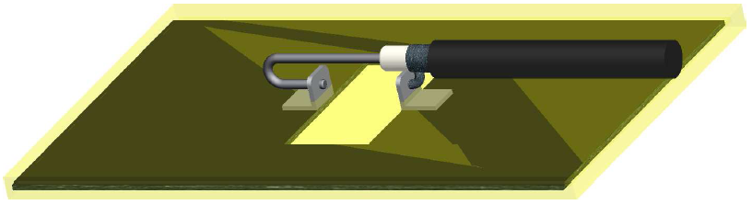

## Design 1

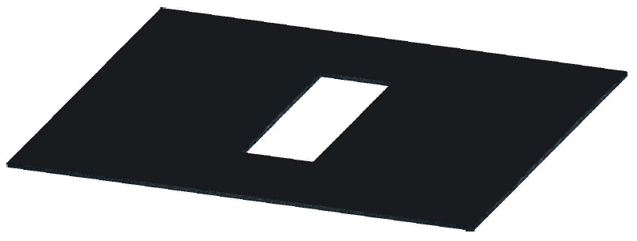The first design is constructed from either single walled or double walled carbon nanotube buckypaper (SWCNT or MWCNT). The buckypaper will be manufactured at the High Performance Materials Institute located near the FAMU-FSU College of Engineering. The decision for whether to use SWCNT or MWCNT buckypaper will be discussed later in Analysis and Testing. Buckypaper is expected to function as a better platform and more workable material than the CNT forest. The dimensions of the buckypaper (disregarding thickness until analysis and testing) will be 8” x 4.8” with a slot area removed from it that is 2.46” x 1.23”. The slot dimensions were established to meet the 2.4 - 2.5 GHz range. The slot’s length will run across the width of the buckypaper sheet as seen in Figure 1.

Figure 2 8” x 4.8” buckypaper sheet with 2.46” x 1.23” slot removed.

The next step is to attach electrical leads to the antenna and encase it in a composite shell. Soldering will not be used to attach the leads due to the intense heat that is involved. Instead, a liquid silver adhesive will be applied to attach the leads. After the leads are securely attached, the conductive material will be encased by a PMMA composite shell to give it structure and support. The leads will extrude from the surface of the composite, which will be Poly(Methyl Methacrylate), also referred to as PMMA.

This design was initially chosen because it deals with buckypaper, currently the most commonly used application of carbon nanotube technology. Buckypaper exhibits desirable electrical properties while still being lightweight and very strong. A buckypaper antenna is not hypothesized to have as much gain as a typical copper or aluminum antenna, it will most certainly provide increased strength over them at a much lower weight.

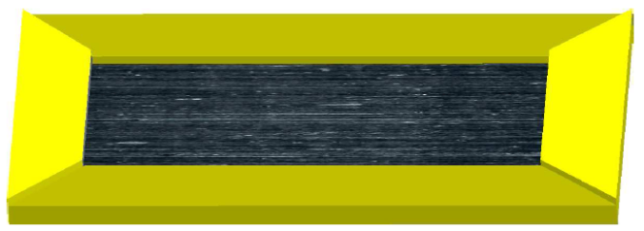Nonetheless this design is anticipated to successfully function as a working slot antenna, there are two options that can be considered as further implementations in order to fulfill the “slotless” design specifications. The first option will involve the slot-area material that was initially removed. This material will be trimmed down 1/8 inch on all sides, lined with a 1/8 inch thick insulated tape and reinserted into the antenna (see Figure 3). In doing so, the design will still be functional while at the same time provide an entirely solid slot antenna.

Figure Buckypaper slot area lined with insulating tape.

The second option will be similar to the first. However, in this case buckypaper that has been fabricated from only semiconducting CNTs will be reinserted. This option will prove to be the more costly as it will require our project team to purchase the CNTs from an outside vendor. Consequently and in order to reduce costs, HPMI personnel’s expertise on buckypaper will be utilized to create semiconducting buckypaper. This one will be cut to the slot area dimensions and inserted into the antenna slot where leads will be soldered and encase the antenna in PMMA.

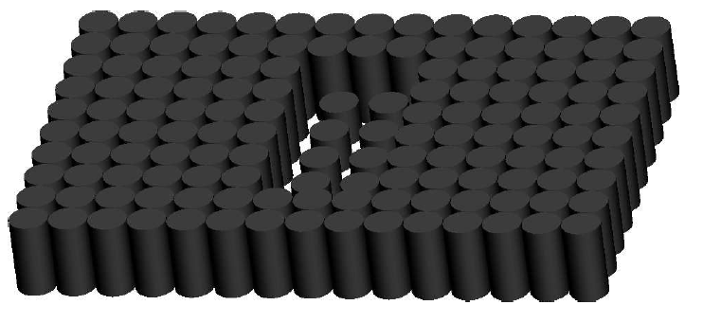

Longer CNTs

Shorter CNTs

## Design 2

The second design will differ from the first in that it will deal with raw CNT forests. The overall dimensions will be the same as Design 1(8” x 4.8”); this size is compatible with the Chemical Vapor Decomposition (CVD) machine at the HPMI. When CNTs are grown as vertically aligned forests, the sheet conductivity perpendicular to the forest is very poor as opposed to the conductivity along their height. This is due to the microscopic contact points between CNTs which increase as a function of the forest density. Furthermore, the sheet conductivity will also increase as a function of the height of the forest. The idea behind this design is to manipulate CNT growth in order to have an entire forest of CNTs with a slot area within it that exhibits much shorter ones; these short CNTs will experience a much lower conductivity. As a result of this, the current flow within the forest will flow around the shorter “slot area” and in essence create a functional slot antenna (see Figure 4).

Figure Long CNT forest (800 µm) with a forest of shorter CNTs (200 µm) embedded within it

The first step in creating this design will be growing the longer CNT forest. This forest will be grown for 60 minutes using the CVD machine at HPMI resulting in a height of approximately 800 µm. Once again, the dimensions will be 4.8” x 8”. Next, using a cylindrical glass roller (diameter of 0.25 inches) forest will be rolled down across its width (see Figure 5). In doing so, the sheet’s conductivity can be augmented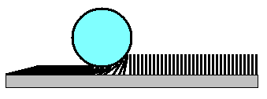 by increasing contact points between CNTs. Additionally, a forest of shorter CNTs for 10 minutes resulting in a height of 200 µm. This forest will not be rolled down and will experience a very low conductivity. Next, the longer CNT forest will be transferred to a sheet of PMMA with dimensions 5.05” x 8.25”. The PMMA will have an area of dimensions 2.46” x 1.23” removed from it via a precision laser cutting device such that it will not pick up CNTs in the removed area. Then, the shorter CNT forest will be transferred to a PMMA sheet of dimensions 2.46” x 1.23” and this sheet of PMMA will be inserted into the original PMMA sheet (consisting of longer CNTs). These two sheets will be heat-fused together. The result will be a total area of CNTs with dimensions 8” x 4.8” on top of a PMMA sheet. Finally, electrical leads will be attached to the longer CNT area on both sides of the shorter CNT area (across its width) via liquid silver adhesive. Finally, another sheet of PMMA will be used to encase the entire design.

Figure CNT forest will be rolled down with a cylindrical glass roller resulting in a greater density and increased conductivity

The design was chosen as an exploration of the properties of CNT growth manipulation. It will prove to be the least costly design as it deals with only raw CNT forests; they will not undergo any sort of further fabrication (eg. Buckypaper). However, the longer CNT forest is not expected to have higher conductivity values than those of buckypaper (even after being rolled down). This will adversely affect the performance measures for the antenna and will be further investigated in analysis and testing.

# Structural Analysis

In order to provide the structural support that is needed to fulfill the design specifications, the team has chosen to encase the CNT antenna in PMMA (Poly(methyl methacrylate)) sheets. Sometimes referred to as plexiglass, PMMA is a durable composite used in a wide variety of applications; one such application is the barrier around hockey rinks that keep the hockey pucks from striking spectators in the stands.(1) With this in mind, the durability of PMMA is being considered as the most favorable option to withstand the environment threats to which the antenna may be exposed. PMMA is proven to be more resistant to the environment hazards than most plastics, as was found in testing done in the harsh climates of Saudi Arabia.(2) Consider the following circumstance:

A rock of approximate size 1.5 x 1.5 x 2 cm is traveling at a velocity of 75 m/s (~250fps) and strikes the PMMA encased antenna structure. In regards to the Conservation of Momentum, the Impulse (N*s) of this collision is found with the following equation:



Equation

where *m* is the mass of the rock and $∆v$ is the rock’s change in velocity (assumed to have a final velocity of zero). The density of the rock will be assumed to be 2.5 $\frac{g}{{cm}^{3}}$. Then, using the following relation



Equation

and assuming the time of impact ( $∆t$) to be 1 millisecond, we calcuate an average force ($F_{AVE}$) of 843.75 N. Since the impact of a rock on the antenna would result in a very localized stress pattern, we consider the weakest point of the antenna structure to be the areas located at each end of the removed slot material ( see Figure 6). Assuming a PMMA thickness of 3mm, the resulting cross sectional area of this region is ${89.15mm}^{2}$. Using the following equation for applied stress:



Figure Weakest point on antenna structure will be at each end of the removed slot material (an area of dimensions 1.17 inches)

Equation

the resulting stress on the PMMA is 9.46 MPa. Comparing this to the Ultimate Tensile Strength of PMMA, 47-70 MPa (Maropolymeronline.com), we conclude that the strength of PMMA is great enough to withstand impacts from rocks or other debris which may compromise the structural integrity of the antenna.

# Measurement Management

In order to effectively complete the project a measurement management strategy has been implemented during this phase. This approach allows the team to facilitate prioritization of deliverables, adopt a value-add mentality and quickly identify major areas for improvement. In addition to this, the collection of objective discrete data and baseline measurements allows the project to move forward and evaluate the impact of decisions on our antenna’s dimensions and raw materials.

In regards to our specific antenna design, the slot antenna is a sheet of conducting material that has a slot physically removed from the sheet. The voltage applied to the antenna makes a current flow through it, thus creating the electric field needed to transmit or receive signals.

Figure 7 Conductivity relationship with signal radiation

Based on previous research, carbon nanotubes have the capability of conducting current. A highly conductive material based from CNTs will allow the antenna to create a magnetic field that will radiate a signal to communicate with others (see Figure 7). It is important to understand that resistance (R) is inversely related to conductivity ( $σ)$ (see Equation 4).

$R=ρ\frac{L}{A} σ=\frac{1}{ρ}$

Equation Resistance and Conductivity Formulas

(L =length, A = Area, $ρ$ = Resistivity)

Due to these relationships, during this measure phase the data collected will be primarily on these two properties. It is expected that with these results, the optimal CNT application material will be chosen and will provide the foundation needed for a functional antenna.

## Operational Definition

As part of the measurement management strategy, an operational definition has been established to accurately guide the data collection of this project. The materials that will be tested include, aluminum, copper, single wall nanotube buckypaper, multi wall nanotube buckypaper and a carbon nanotube vertically aligned forest. In order for our team to successfully produce and good antenna, relevant material was gathered for the project. Considering the design concepts, the materials chosen for our baseline measurements were copper and aluminum. In modern antennas, these are the most conductive and popular materials for these applications. The various samples can be observed in figure 8.

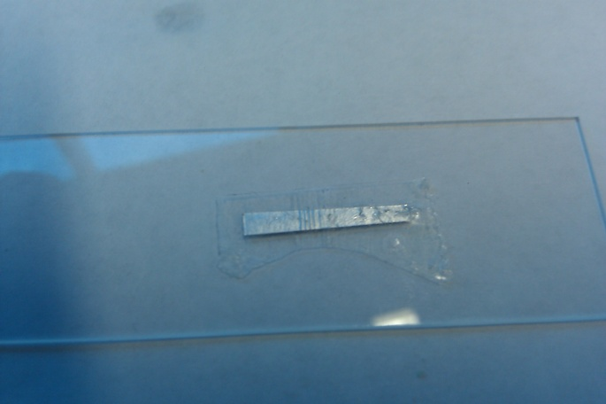 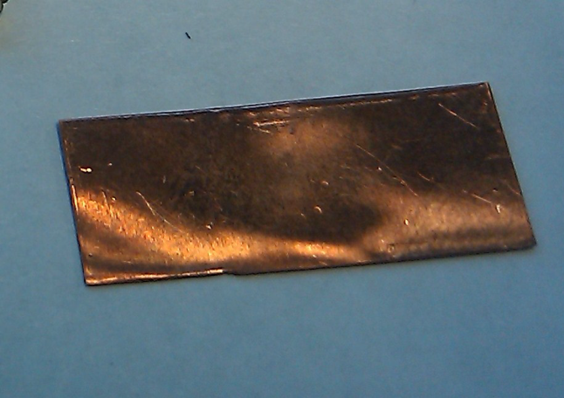

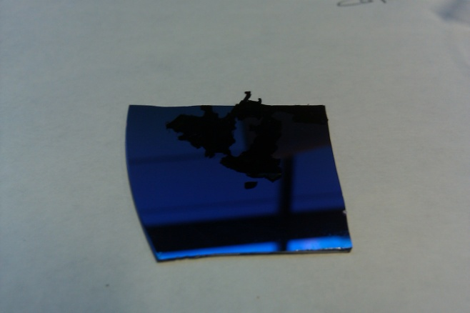 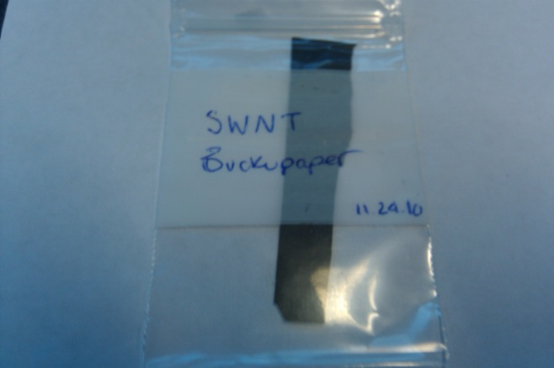

Figure (Top row from left to right) Aluminum foil and cupper sheet. (Bottom row from left to right) CNT Forest and SWNT Buckypaper 91)

These samples’ conductivity, resistance, resistivity, density and thickness will be measured. Without consistent and useful values of resistivity and conductivity, it may be deemed infeasible to make a carbon nanotube antenna since so many aspects such as radiation resistance and the radiation pattern depend on these factors. Now, the scope of this measurement phase has been redefined for this specific phase due to the lack of equipment availability. As of now, besides conductivity and resistivity, additional in scope measurements are our samples’ length, width, and height since these are needed to operate the equipment currently available. The density was also calculated from the data measured and tabulated in order to compare the weights of antennas.

With respect to measurements out of scope, the antenna’s gain, frequency and radiation pattern have not been measured due to the lack of equipment availability. Currently, the team does count with a metal based antenna that could be tested. Further steps in order to address this issue will be taken during the analysis phase with the help of the electrical engineering department and Harris Corporation.

The two different measurement machines used during this phase were provided by Dr. Englander and by the High Performance Materials Institute. Due to this, two sets of data will be explained and analyzed in the data and analysis section. In reference to the equipment, the HPMI allowed the use of the following:

* 1. Electron Microscope
     1. Olympus BP X40 Microscope & Analysis: Used to measure width of samples. Width was needed for the Labview Software.
     2. Labview Software: Displays current vs. voltage curve in order to obtain the slope or resistance of samples.
  2. Heidenhain: Thickness testing machine
  3. Four Connect Probe (see Figure 9)
     1. Plate with 4 lines of semiconducting metal
     2. Outside wires transported current
     3. Inside wires measured change in voltage
  4. Current Supplier and Reader
     1. Nanometer: This device monitored the voltage drop on a nanoscale as the experiments were happening
     2. Voltmeter: Induced current into the samples.

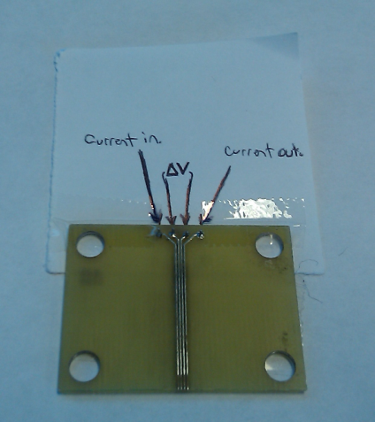

Figure Four probe system

The second piece of equipment was provided by Dr. Englander. Below in figure 10, the Keithley semiconductor characterization system and the alligator clips are displayed. Through the use of this one, resistance values were obtained from all of our samples and even the folding of multi wall nanotube buckypaper. This system exposed a greater suitability for larger samples rather than smaller ones such as the CNT forest.

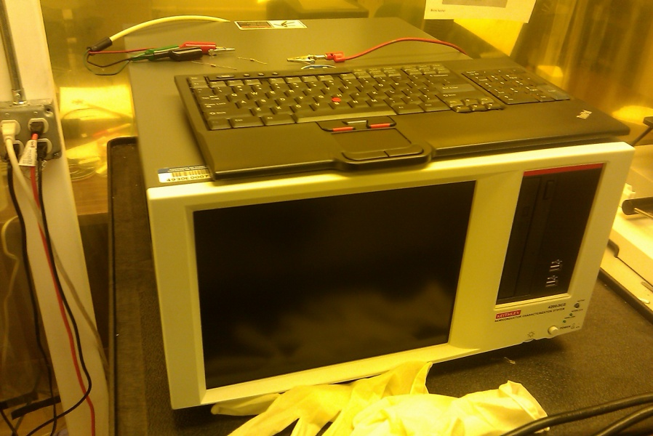 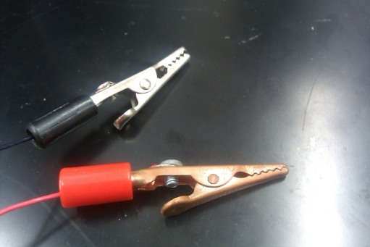

Figure 10 Keithley Semiconductor Characterization System

The measurement plan served as an ideal tool for accurate data collection. Table 2 displays the specifics of this plan and data collection distribution among the team’s members.

|  |  |  |  |  |  |  |  |  |  |
| --- | --- | --- | --- | --- | --- | --- | --- | --- | --- |
| **Measurement Plan** | | | | | | | | | |
| **Performance Measure** | **Operational Definition** | **Data Source/ Location** | | | **Sample Size** | **Who will collect the data** | **When will data be collected** | **How will data be collected** | |
| **Conductivity 1** | Electrical conductivity of samples | | HPMI | | 7 | Justin, Brian | 11/22/2010 | | Retrieved from Machine |
| **Conductivity 2** | Electrical conductivity of samples | | | Keithley Semiconductor Characterization System | 7 | Justin, Jolie & Natalia | 11/24/10 | Retrieved from Machine | |
| **Thickness** | Thickness measurements | | | Heidenhain | 3 | Justin, Brian | 11/22/2010 | ... | |
| **Resistance 1** | Resistance measurements | | | HPMI | 7 | Justin, Brian | 11/22/2010 | ... | |
| **Resistance 2** | Resistance measurements | | | Keithley Semiconductor Characterization System | 1 | Justin, Jolie & Natalia | 11/24/10 | Retrieved from Machine | |
| **Density 1** | Density calculations | | | Calculated from weight and volume | 7 | Edwisht | 11/22/2010 | Calculated in Excel | |

Table Measurement Plan

# Results and Data Analysis

The results that were gathered followed expected trends. The resistance of the samples was found from the current versus voltage graphs and using the geometry of the sample we calculated the resistivity. The results of this can be found in figure 11.

Figure Resistivity

As seen in the graph, the highest resistance came from the carbon nanotube forest. It was hypothesized that this would be true, since the resistance is greater perpendicular to the CNTs length as opposed to running down the CNT like electricity through a wire. Since such a high resistivity was found, the CNT forest will not be used in our final design.

From the resistivity we calculated the conductivity; copper was expected to have the best conductivity, while the CNT methods were expected to have lower conductivities. As seen in figure 12, the results of testing verified the literature.

Figure Conductivity Testing

Also seen from these results is the conductivity of single walled CNT buckypaper and multi walled CNT buckypaper. These are not near the conductivity of aluminum or copper, but there is hope in stacking multiple sheets of buckypaper together to increase the cross sectional area and reduce the resistance of the sheets. A simple experiment was done where buckypaper was folded and the resistance across the sheet was then measured. The results can be seen in figure 13.

Figure 13 Folded Buckypaper Resistance

As seen in the figure, the resistance did increase from unfolded buckypaper. This is due to the multiple sheets of buckypaper being used, which increases the cross sectional area while keeping the same length (refer to resistivity equation 4). What was surprising about these results was the resulting conductivities that were achieved from folding. It appeared that conductivity did slightly increase as the sheet was folded more. This could be from carbon nanotubes in the separate sheets making connections between the sheets, or it may just be due to discrepancies in the machine. More analysis and testing is needed before a definitive conclusion may be made. The results can be seen graphically in figure 14.

Figure 14 Folded Buckypaper Conductivity

Finally, all of these results are tabulated and compared to the results found through literature in table 3. As can be see, all of the values are off by a power of ten in most cases. The sources of error leading to these results will be discussed in the next section. Due to this discrepancy however, our final design follows the results found from the experiment conducted rather than what the results should be, since the capabilities of other labs may be different than that available at Florida State University.

|  |  |  |  |  |
| --- | --- | --- | --- | --- |
| **Material** | **Resistivity (Ohm m)** | | **Conductivity (S/m)** | |
| Experimental | Actual | Experimental | Actual |
| **Aluminum** | 1.71E-03 | 3.00E-08 | 1.20E+07 | 2.40E+07 |
| **Copper** | 6.01E-04 | 1.68E-08 | 2.22E+05 | 5.69E+07 |
| **SWNT Buckypaper** | 9.44E-04 | 4.90E-05 | 1.15E+03 | 2.04E+04 |
| **MWNT Buckypaper** | 1.94E-04 | 5.00E-05 | 5.52E+03 | 2.00E+04 |
| **CNT Forest** | 1.31E-02 | 8.00E-03 | 8.09E+03 | 1.25E+02 |
| **CNT Rolled Forest** | 1.31E-04 | 5.00E-05 | 7.63E+03 | 2.00E+04 |

Table Experimental and Actual Values

## Sources of Error

Given the deviance from literature values, there are some sources of error that should be discussed. First is the quality of the measurements taken need to be analyzed. With the four probe device (figure 9), the samples had to make perfect contact between the probes, which took a little manipulation of the sample. Without perfect contact, the measurement would be off. The buckypaper had less of a problem with contacting the probes since it is a thinner material and could be pressed in between the probes for more contact. The metal had a harder time because it is a stiffer material, and could not conform to the probes as well. Poor contact between the probes and the samples lead to higher resistivity, which also corresponds to poor conductivity.

The difference between the two testing devices can be explained also. The smaller four probe device was built to take CNT and buckypaper resistivity measurements, however the Keithley Semiconductor Characterization system is able to take measurements of all samples. Since this device is not specialized, any results taken from it are able to be compared directly. However, without this specialization, it also leads to not as precise measurements as a specialized device would.

Another source of error comes from the sizing of the samples. The samples that were tested with the Keithley Semiconductor Characterization system were closer in size to that of the proposed antenna, the longer length and thickness leads to differences in the CNT and buckypaper measurements, whereas the four probe device could only measure samples that were millimeters in length and width. CNTs are excellent conductors along the length of the tube itself, so measuring the conductivity in small distances will lead to a higher conductivity, since the connections are along the length of a few nanotubes instead of many. This could explain the difference between the CNT measurements between the two devices.

In regards to the difference between the conductivity between CNTs and metal, the problem comes in having good connections between the nanotubes themselves. In metals, there is a lattice of atoms combats this that all share electrons; this is what makes them good conductors of electricity. CNTs rely on connections between individual tubes to convey electrons through the bucky paper sheet. Any disconnect between nanotubes leads to a decrease in conductivity. It will be the optimization of the connections between carbon nanotubes that will determine whether they can be used in this antenna application.

# Final Design

Referring back to Results and Data Analysis, the data shows that the best antenna in regards to electrical performance will be the buckypaper antenna. More specifically, the buckypaper that is constructed from multi-walled carbon nanotubes (MWCNT) will outperform buckypaper made from single walled CNTS; Table 3 illustrates these findings. Furthermore, the finished antenna design will not be constructed from a single sheet of buckypaper. The entirety of the antenna will be constructed from several sheets of buckypaper that have either been stacked, folded, or a combination of both (depending on the overall dimensions of buckypaper that are available to us). The reasoning for this can be modeled as resistors in parallel (see Figure 16). When multiple sheets of buckypaper are used in parallel, the overall resistance can be found with the following relation:

Figure Dimensions for the finalized antenna designs to be constructed during the spring semester

$R_{T}={\left(\frac{n}{R}\right)}^{-1}$

Equation Equivalent Resistance

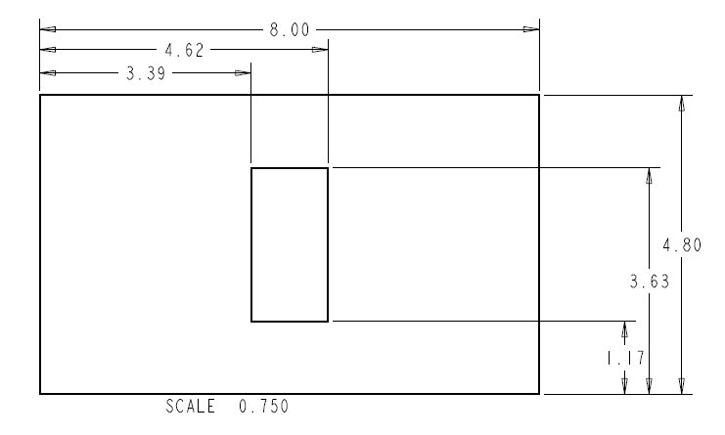where R is the resistance of the buckypaper and *n* is the number of sheets that are stacked. By stacking enough buckypaper sheets it is possible to achieve a much lower resistance and more desirable conductivity.

R

R

Being limited by a $2500.00 budget, two buckypaper antennas will be constructed; each consisting of 7 sheets of buckypaper. Using equation 5 and referring to Figure 13, the resistance of each buckypaper antenna should theoretically equate to be 2.83 Ohms. The dimensions of each antenna are shown in the drawing in Figure (number). The process of constructing each antenna is as follows:

Figure Resistors used in parallel result in a lower total resistance. Stacked sheets of buckypaper can be modeled this way

1. Fold and stack buckypaper sheets. This step will be dependent upon the size of buckypaper sheets that are available to use. Sheets cannot be folded such that the resulting dimensions are smaller than those that have been previously specified.
2. Buckypaper stacks will be cut to the specified dimensions using a precision cutting knife or razorblade. Removed slot-area pieces are NOT to be discarded.
3. Center aluminum leads to each side of the slot area across its width. Leads will be attached via conductive liquid silver adhesive and given enough time to fully cure.
4. Entire antenna design will be encased within a PMMA shell. Special care will be taken in order to leave the aluminum leads extruding from the surface of the PMMA shell.
5. Stripping back the layers of a coaxial cable, the inner wire will be attached to one lead while the outer mesh will be attached to the other. The antennas are now ready to be tested for congruent radiation patterns.

In order to achieve the “slotless” design specification, there were two options that could be done. The first involved the 2.46 x 1.23 inch material that was removed from center of the buckypaper sheets. These sheets would be trimmed down 1/8 inch on each side and then lined with 1/8 inch insulating tape. Next, they would be reinserted into the original buckypaper sheets from which they were removed (taking place after step 3). The finished product will be an entirely solid slot antenna with greater uniformity and structure. However, it may affect the working dimensions of the slot area. These dimensions will have to be recalculated based on the dielectric constant of the slot area and insulating tape. The second option was to purchase only semiconducting CNTs from an outside vender to fabricate semiconducting buckypaper. This buckypaper would have been inserted into the original buckypaper antenna (after step 3) before being encased in PMMA. This option would prove to be more structural sound as it does not introduce any material other than CNTs into the design (unlike Option 1). However, the price of only semiconducting CNTs is typically within the range of $150.00 per mg: 1000 times more expensive than MWCNTs. Also, the working slot dimensions will need to be recalculated for this option as well. With both of these options being considered, the decision is to use Option 1. Option 1 is subjected to the same dimensional problems as Option 2 while still falling within the project budget.

# Cost Analysis

Considering the final design, the following materials will be required to manufacture two optimal prototypes as explained above (see table 4). The team will incur in additional expenses once the final design is manufactured. Additionally, travel expenses such as gas have been taken into account and can be observed in table 5.

|  |  |
| --- | --- |
| **Material** | **Quantity** |
| PMMA | 3 Sheets |
| Insulating Tape | 1 Roll |
| Coaxial Cable | 3 Cables |
| Isopropyl Alcohol (IPA) | 1 Gallon |
| Surfactant (Triton X 100) | 500 mL |

Table Bill of Materials

|  |  |
| --- | --- |
| **Expense** | **Cost** |
| Buckypaper Folded Antenna Design | $609.00 |
| Buckypaper Stacked Antenna Design | $609.00 |
| Final Antenna | $730.00 |
| Travel Expenses | $240.00 |
| **TOTAL** | **$2,188.00** |

Table CNT Based Antenna Project Budget

The team counts with a budget of $2,500 dollars. As stated in table 2, the total estimated expenses give a total of $2,188.00. Consequently, there will be approximately $312.00 available for any unexpected expenses.

# Future Plans

Figure Future Plans Flow Diagram

With the culmination of the measure phase, the analysis stage will begin (see Figure 17). During this phase, an in-depth analysis of material and design options will take place. The team will analyze previous data collected and apply a design of experiments approach to accurately rate the changing factors that can improve our design concepts. Some of these factors will include length, width, and number of buckypaper sheets among others. Given the results from the design of experiment, the team will then proceed to the manufacturing of the top two design concepts. With the manufacturing of these two antennas, the team will be ready to enter the design phase and test these prototypes. In the design phase, further improvements will be defined to accurately meet the specifications given by Harris Corporation. The verify stage will allow us to verify our design performance and successfully deliver a functional product to our sponsors.

# Conclusion

In conclusion, the design that will be focused on in the spring semester will be composed of buckypaper. Special attention will be given to increasing the conductivity of the buckypaper sheets in order to get the conductivity needed. Without a conductivity that is close to that of metal, a functioning antenna will be impossible to make. Using the design of experiment approach on the antenna dimensions, there is hope in creating a buckypaper antenna that will have the conductivity needed. This antenna will be lighter than metal antennas due to the buckypaper being less dense than both aluminum and copper, allowing for the creation of a lightweight final prototype. As mentioned before, PMMA will be strong enough to encase the buckypaper to provide stability, while also not adding much to the budget cost. The total expected cost of this project will be $2,188.00. Most of the expense going towards the buying of CNTs for the antenna. At the end of the spring semester, after the testing of two prototype antennas, it is expected that a buckypaper antenna will be fabricated and brought to the Harris Corporation to be tested.

# Bibliography

1. Pham, G. T., Park, Y.-B., Wang, S., Zhiyong, L., Wang, B., Zhang, C., et al. (2008). Mechanical and Electrical Properties of Polycarbonate Nanotube Buckypaper Composite Sheets. *Nanotechnology* (19).

2) Park, Jin Gyu, Jeffrey Louis, Qunfeng Cheng, Jianwen Bao, Jesse Smithyman, Richard Liang, Ben Wang, Chuck Zhang, James S. Brooks, Leslie Kramer, Percy Fanchasis, and David Dorough. "Electromagnetic Interference Shielding Properties of Carbon Nanotube Buckypaper Composites." *Nanotechnology* 20.41 (2009): 415702. Print.

3) Wang, Ding, Pengcheng Song, Changhong Liu, Wei Wu, and Shoushan Fan. "Highly Oriented Carbon Nanotube Papers Made of Aligned Carbon Nanotubes." *Nanotechnology* 19.7 (2008): 075609. Print.

4) Zhao, Bin, Don N. Futaba, Satoshi Yasuda, Megumi Akoshima, Takeo Yamada, and Kenji Hata. "Exploring Advantages of Diverse Carbon Nanotube Forests with Tailored Structures Synthesized by Supergrowth from Engineered Catalysts." *ACS Nano* 3.1 (2009): 108-14. Print.

5) Sadgrove, Kit. "The Complete Guide to Business Risk." *Google Books*. Web. 29 Nov. 2010. <http://books.google.com/books?id=PHiJ_l8nN8AC&printsec=frontcover&dq=business risk management&source=bl&ots=LVHgNLUV6k&sig=h87XsL-Oz2neH_o3JbdhXlKhHEE&hl=en&ei=ffryTLLzLZG2sAPaj9zCCw&sa=X&oi=book_result&ct=result&resnum=7&sqi=2&ved=0CFoQ6AEwBg#v=onepage&q&f=false>.